**BUDGET ANALYSIS AND REMINDER**

**INCREMENT #3**

Submitted by

Sampath Madineni (16185610)

Haricharana Kanamarlapudi (16186977)

Sandhya Sannapareddy (16181402)

Raghavendra Chirumamilla (16187866)

* **Objective:**

1. When user successfully logins into application, he/she can add, update and delete a new expense or family budget expenses
2. User can view the list of individual expenses and family expenses and can also update or clear the list
3. User also has a facility to view his weekly, monthly, yearly budget graphically using bar graphs.
4. User can update his own expense or a family budget expense if he is included in that expense.

* **Import Existing API or Services:**

Graph API to view weekly, monthly, yearly and endless budgets

* **Detail Design of Services:**
* **User stories using ScrumDo:**

**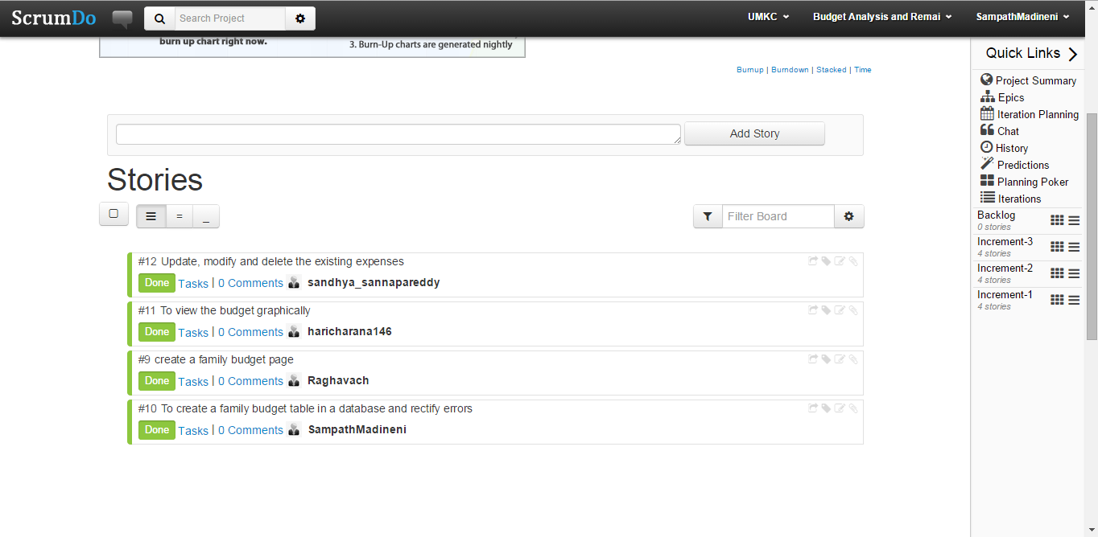**

* **Service Description:**

**Create family budget:-**

User can create his family budget in weekly, monthly and yearly basis. He can set the limit of budget for that particular term. User will be provided with a option to select starting and ending dates of his term budget.

**View budget graphically:-**

User can view his weekly, monthly, yearly and endless budgets through bar graphs so that he can have clear view of his budget and expenses.

**Modify created budgets:-**

User can edit, update and delete the existing expenses from database.

* **Sequence Diagram:-**

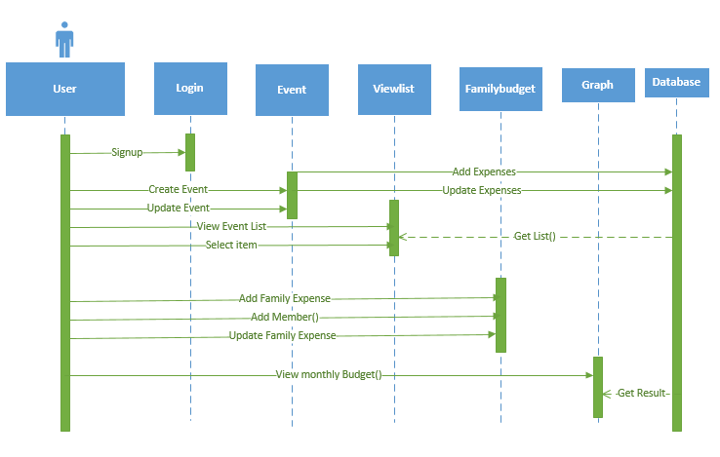

* **Class Diagram:-**

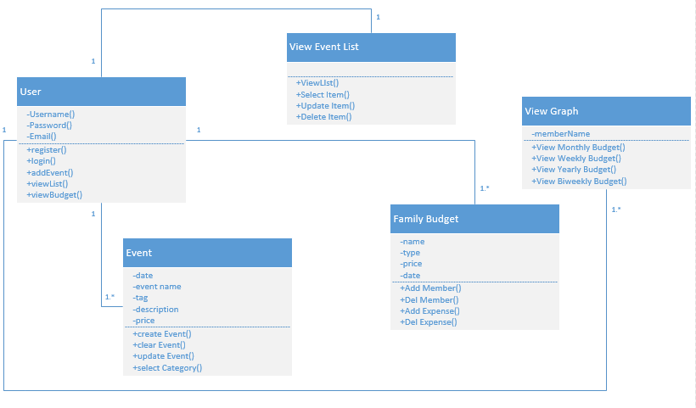

* **Design of Mobile Client Interface:**

**Hardware Requirements:-**

A touch enabled smart phone with LED screen

RAM of capacity 512 MB

SD with minimum memory of 50 MB

1GHz processor or Dual core processor

**Software Requirements:-**

Operating System : Android

Version of operating system : gingerbread(2.3) or advanced

* **Implementation:**
* **Implementation of User Interface:**
* After the successful login by user a list of activities such as add new expense, view list, add family budget and view graph will be appeard on home screen.

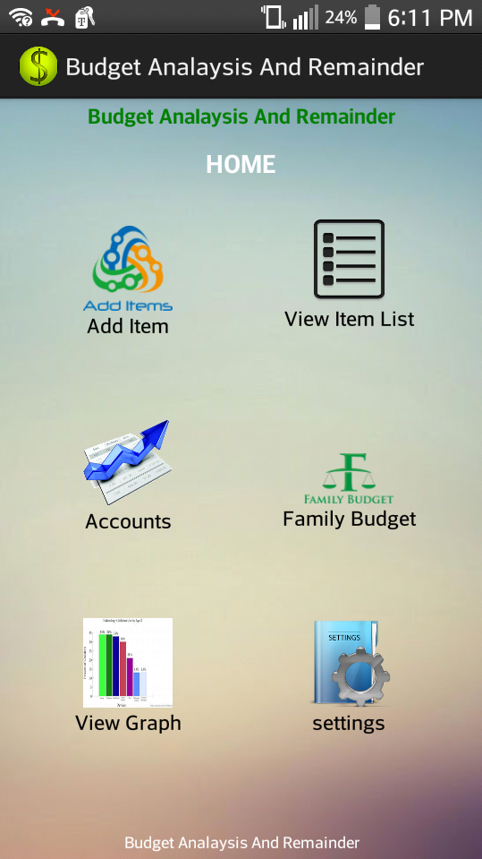

* user can add a new expense by selecting add item icon on home screen. Then user can add an expense by giving required credentials such as date, description and price. If all information is correct he selects save else user selects clear button.

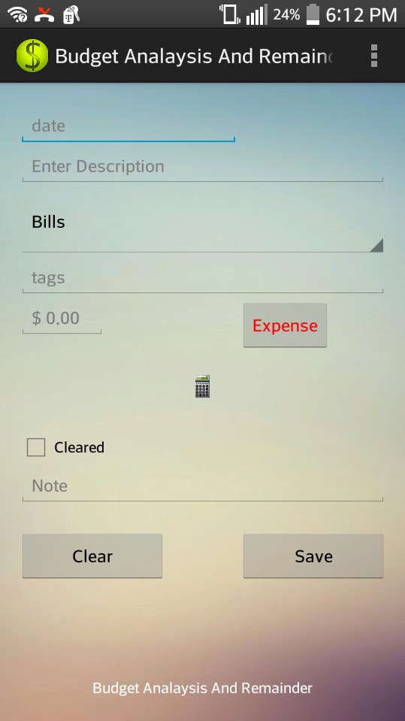

* User can add a family budget by selecting family budget from home screen. User also provides starting and ending dates for the budget.

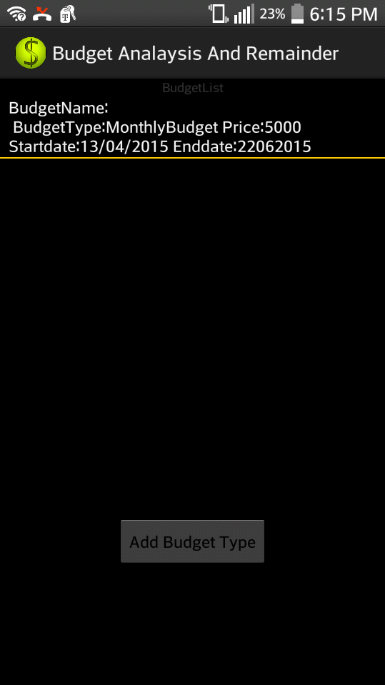

**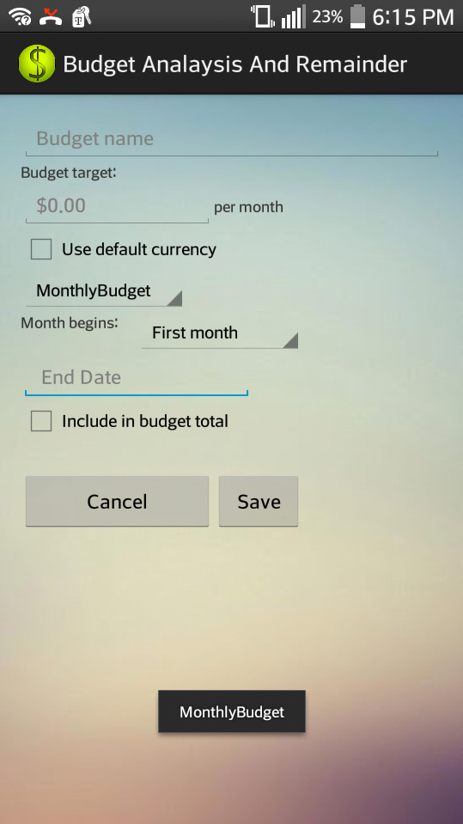**

* User selects whether it is weekly, monthly or yearly budget from dropdown list. He can also provide starting and ending dates for the budget.

**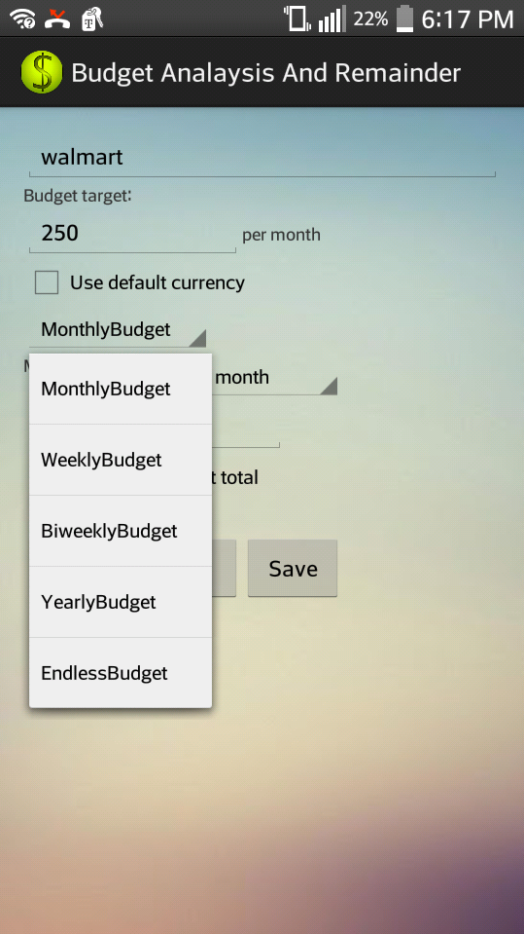**

**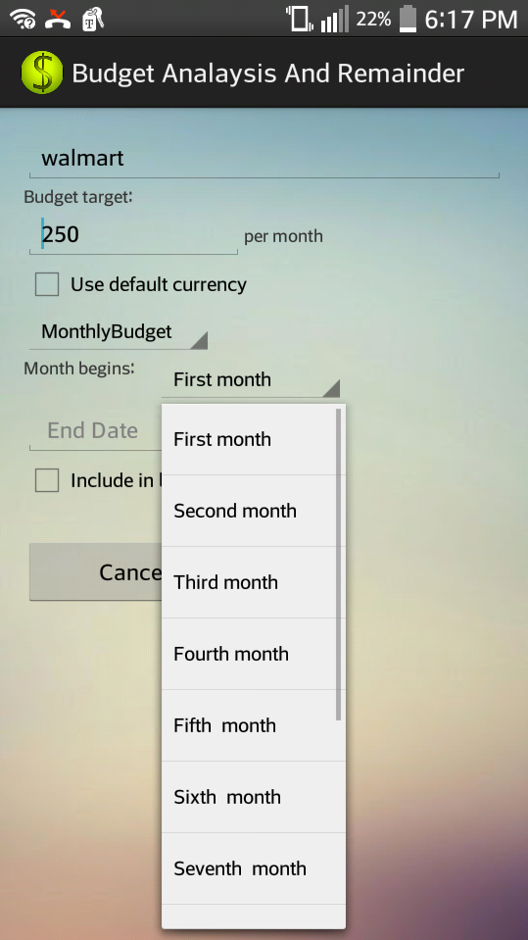**

* After entering the details the user selects save button, then the details will be saved to database and can be viewed in a list.

**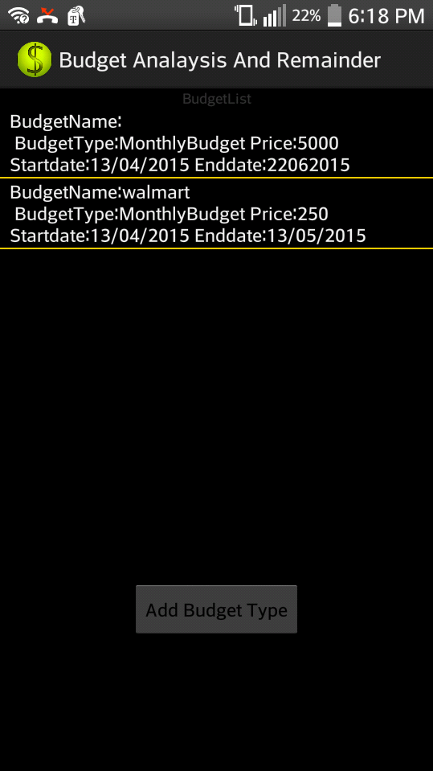**

* **Testing:**

**Positive Test cases:-**

* When the user enters correct budget details and saves them it will be added to database and displays in a list

**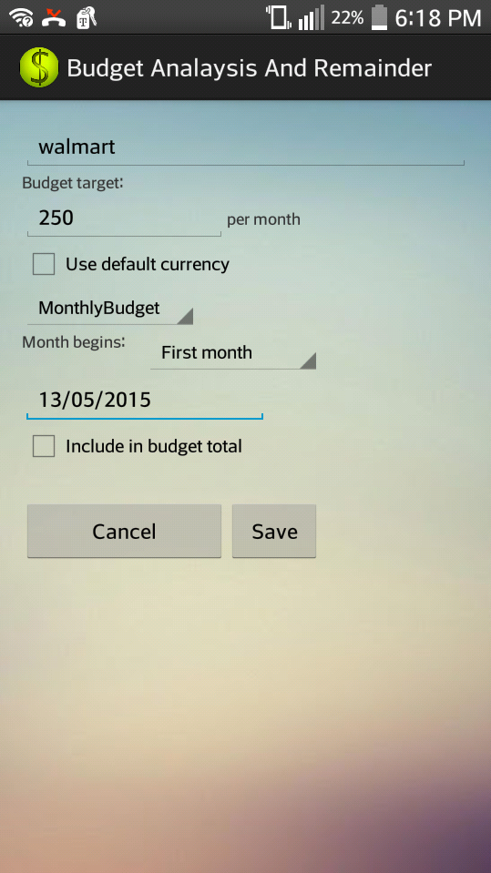**

****

**Negative test cases:-**

* When the user tries to add the same expense for the second time a message will be displayed, as expense already exists

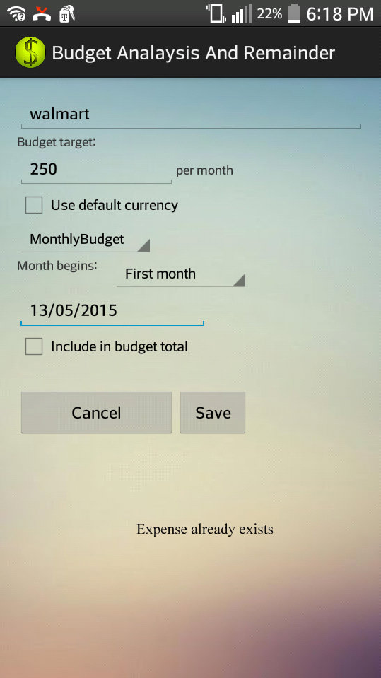

* **Deployment:**
* **SrumDo:-**

[https://www.scrumdo.com/projects/project/budget-analysis-and-remainder4/iteration/126370](https://www.scrumdo.com/projects/project/budget-analysis-and-remainder4/iteration/126370" \t "_blank)

* **GitHub:-**
* **Project Management:**
* **Work completed:**

**Description:-**

1. Create family budget
2. Update, modify or delete existing expenses.
3. Graphical representation of budget
4. Created table for family budget in database

**Responsibilities:-**

*Sampath Madineni:-*

Created a table for family budget and rectified errors such as delete option in database table. Also helped for creating a family budget page.

*Haricharana :-*

Using the graph API displayed all the budget details for weekly, monthly and yearly basis in a bar graph view.

*Sandhya Sannapareddy: -*

When user finds any errors in saved expenses he can modify, update or delete the expenses from the database.

**Time Taken:-** 15 days

**Contribution:-**

Sampath Madineni:- 25%

Hari charana :- 25%

Sandhya Sannapareddy :- 25%

Raghavendra Chirumamilla :- 25%

* **Work to be completed:**

No work dues for this increment

* **Issues/concerns:**

1. Faced difficulties in linking graph API’s to application and display them in weekly, monthly and yearly basis.
2. Updating the existing the existing database.